SOUTH TONGU MUNICIPAL ASSEMBLY



2025 ANNUAL ACTION PLAN

OCTOBER, 2024

CHAPTER ONE

1.0 EXECUTIVE SUMMARY

1.1 BACKGROUND, MUNICIPAL PROFILE/CURRENT SITUATION

The Decentralization process in Ghana makes the Municipal Assemblies the pivot of development activities in the country. With the coming into force of 1992 Fourth Republican Constitution of Ghana, the New Local Government System Act 1993, (Act 462), the National Development Planning Commission Act 1994, (Act 479) and the Development Planning Systems Act 1994, (Act 480). The Assemblies in Ghana have been tasked to ensure the overall development of the areas under their jurisdiction through the formulation and execution of Development Plans and programmes and designing strategies for the mobilization and prudent utilization of revenue. Thus, the Assemblies have become the pivot of development activities from the bottom.

In line with this, the South Tongu Municipal Assembly has taken the necessary steps to formulate this Annual Action Plan for 2025. This is meant to form the basis for the implementation of programmes aimed at reducing poverty and laying the foundation for a Holistic Sustainable Socioeconomic Development in the Municipality

1.2 PROCESS OF PREPARING AND ADOPTING THE ANNUAL PLAN

This plan is an extraction of programmes and projects from the Municipal Medium Term Development Plan for 2022-2025. It essentially contains programmes and projects planned for 2025 and those rolled over from the 2024 Annual Action Plan for implementation due to the Assembly’s inability to fully complete them. Their implementation was however deemed necessary for meeting key targets set by all stakeholders in the Assembly. It also contains new priority programmes for 2025. The Annual Action Plan was prepared within the Policy framework of the “an Agenda for Jobs; Creating Prosperity and Equal Opportunities for all, 2022-2025” to address the prioritized needs of the people in 2025. The prioritized interventions are aligned with the Thematic Areas of the President’s Coordinated Programme of Economic and Social Development Policies

1.1 Vision
South Tongu Municipality has a vision to be a Municipal with best practices in local governance, socio-economic development, and natural resource management.

1.2 Mission
The mission of South Tongu Municipal Assembly is to improve the quality of life of the people through effective mobilisation of the human, material, and financial resources for accelerated socio-economic development and creation of enabling environment for private sector participation.

1.4 Location and Size
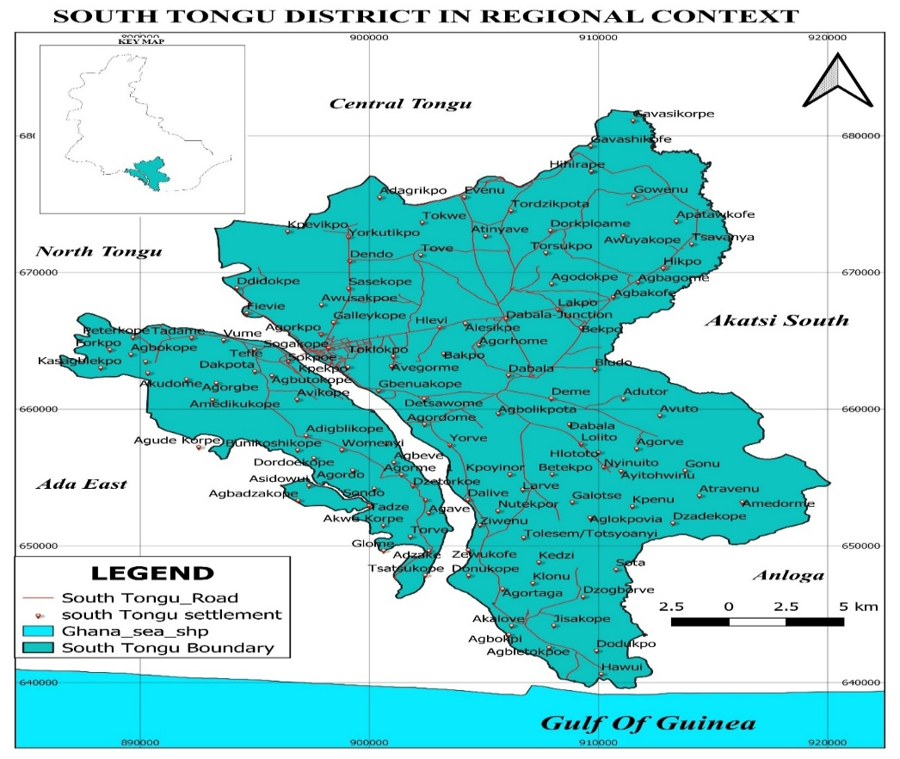
South Tongu Municipality lies between latitudes 6°10’ and 5°45’ North and longitudes 30°30’ and 0°45’ East. It is bounded to the North by the Central and North Tongu Municipals, to the East by the Akatsi South Municipal, to the West by the Ada East Municipal of the Greater Accra Region and to the South by Anloga Municipal and a short coastline. The Municipal occupies a total land area of 665 square kilometres representing 7.0 percent of the land size of the Volta Region (2021 PHC). Figure 1 below shows the map of South Tongu Municipal. Figure 1: Map of South Tongu Municipal

1.5 Governance
a) Administrative Structures
The South Tongu Municipal Assembly was establish by Legislative Instrument (L.I.) 1466 of 1989 as the highest political decision-making body in the Municipality with deliberative, legislative and development powers and functions. The Municipality has one (1) constituency, forty-(40) electoral areas and four (4) Area Councils (Sogakope, Dabala, Larve and Agave-Afedume). It has 60 assembly members including one Member of Parliament (MP) and the Municipal Chief Executive. The Municipal assembly functions through five (5) statutory Sub-Committees (Development Planning, Finance and Administration, Justice and Security, Works, Social Services) and an Executive Committee chaired by the Municipal Chief Executive. The Assembly operates through other committees such as Tourism and Sanitation Sub-Committee, Budget Committee, Audit Committee, Public Relation and Complaints Committee. Thirteen departments exist under the Municipal Assembly to implement policies, programmes and projects of the Assembly.

b) Traditional Administration and Culture
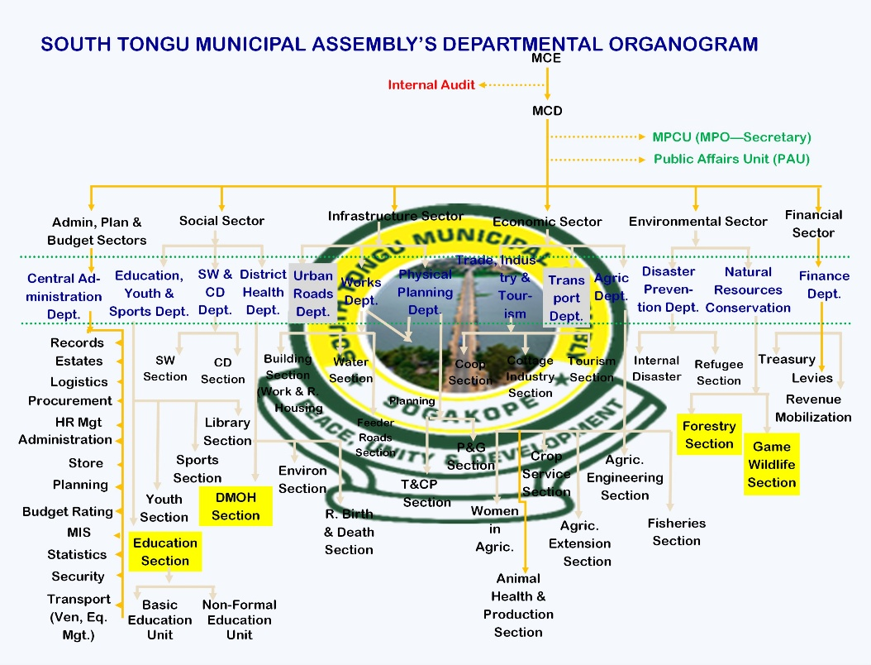
The Municipal has five traditional areas namely Agave, Fievie, Tefle, Sokpoe and Vume with Agave being the largest. Each traditional area is autonomous with its own paramount chief, queen and festival. The people of Agave celebrate an annual Dzawuwu festival during the month of August. Two months prior to the festival, picking of fresh clams/oysters (afoli) is forbidding. Tortsogbeza by the people of Sokpoe is an annual event held during Easter in remembrance of the historical crossing of the Volta River by their ancestors. Kporlegbeza, literally meaning (capture of the tiger), is usually celebrated during Easter by the people of Fievie while Afenorto, which means ‘home coming’, is celebrated by the people of Tefle during the month of December. The festivals bring home all indigenes residing outside their localities to connect with their extended families, promote unity and mobilize resources toward self-help developmental projects. According to 2021 PHC, Ewes dominate the ethnic groups in the Municipal (93.70%), followed by the Ga-Dangme (2.38%) and Akans (2.11%) with an insignificant presence of other ethnic groups (1.81%). In terms of religion, Christians form majority (85.40%) of the population, followed by Traditionalist (5.94%) and Muslims (2.30%). Those who do not profess any religion form 6.35 percent and those who practice other religions constitute 0.01 percent. There is peaceful co-existence among the religious groups in the Municipal.

1.6 Security and Judiciary
On security, the Municipality is generally peaceful with the presence of key security agencies. The security agencies present are Ghana National Fire Service, Ghana Immigration Service and Customs Division of the Ghana Revenue Authority, which operate from Sogakope. The rest are Naval Training Command at Nutekpor and Ghana Police Service with a Divisional Command, which are fairly distributed across the Municipal. The Municipal has a Municipal Court at Dabala, Circuit and High Courts at Sogakope to administer justice. The High Court also serves residents of North Tongu, Central Tongu, Akatsi South and Anloga Municipals. In addition, plans are afoot for the establishment of Police Training School and its ancillary facilities at Atravenu Electoral Area in the Municipal. The presence of these justice and security agencies has significantly contributed to the peaceful environment the Municipal is enjoying.

1.7 Demography
a) Population Size and Distribution
The total population of the Municipal is 113,114 in the 2021 PHC from a figure of 87,950 in the 2010 PHC. The projected population figure for 2025 is 118,825. The Municipal population represents 6.8 percent of the regional population (1,659,040). Females constitute 53.6 percent while males constitute 46.4 percent. The Municipal, which has become largely urbanised, has about 52 percent of its population located in four major towns namely Sogakope, Sokpoe, Tefle and Vume. The Municipal has a total household of about 31,600 with an average household size of 3.5.
b) Age-Sex Structure (Population Pyramid)
As shown in figure 2 below, the Municipal has a large youthful population, which is very active. Provision of any social services or interventions in the Municipal should take account of this youthful structure while not forgetting the aged, which constitute about 8 percent of the total Municipal population.
Figure 2: Population pyramid
c) Spatial Distribution of Population
The population density is high in communities along the major roads namely Sogakope, Dabala, Sokpoe, Tefle, Vume, Agorkpo, Adutor, Kpotame and Agbakope and in few other communities where the road network is good. However, the population is sparsely distributed in the Eastern section of the Municipal where the road networks are poor.
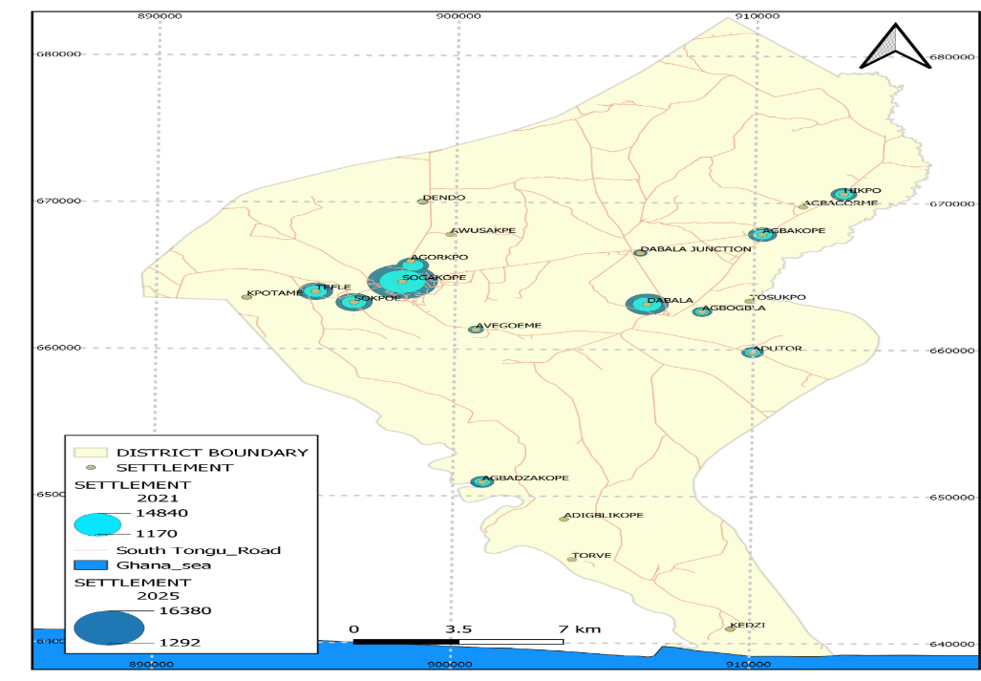
Figure 3: Spatial Distribution of Population

1.8 Settlement Systems and Built Environment
a) Hierarchy of Settlements
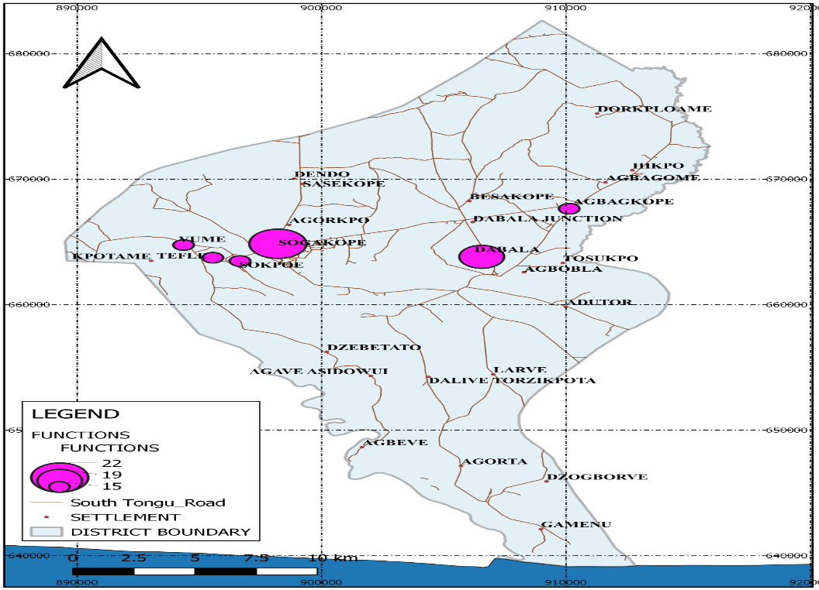
Hierarchy of settlements in terms of functions and services they perform helps to determine functional zones in the Municipal. There are about 104 communities in the Municipal. However, Sogakope, Dabala, Agbakope, Sokpoe, Tefle and Vume are the major towns, which provide most of the services and functions in the Municipal. Sogakope is the principal settlement that hosts the Municipal Assembly and has sub urban towns, which now provide higher services as stated in the table below. This is follow by Dabala, Agbakope, Sokpoe, Tefle, Adutor and Vume, which are fast growing in the Municipal. The location of these towns along the Tema-Aflao highway has turned them into commercial hub for brisk business and other economic activities. The table below shows key services and functions performed by major settlements while figure 4 below is a graphic representation of functional towns in the Municipal.

Table 1: Functional towns
Hierarchy | Settlement | Key services/functions provided | Total services/functions
1 | Sogakope | Basic school, Secondary school, hospital, banking, police headquarters, Area council office, electricity, public toilet, telephone, internet service, potable water, tarred road, agric extension service, guest house/hotels, filling station, court, post office, restaurant, fire service station, market, lorry park, Municipal Assembly office | 22
2 | Dabala | Basic school, Secondary school, banking, police station, electricity, public toilet, telephone, internet service, potable water, tarred road, agric extension service, guest house, filling station, post office, restaurant, market, lorry park, Area council office, health center | 19
3 | Agbakope, Sokpoe, Tefle, Agorkpo, Adutor and Vume | Basic school, secondary school, electricity, public toilet, telephone, internet service, potable water, tarred road, agric extension service, guesthouse, filling station, restaurant. | 15
Source: DPCU Construct, 2024
Figure 4: Map of functional towns

1.9 Transportation Network
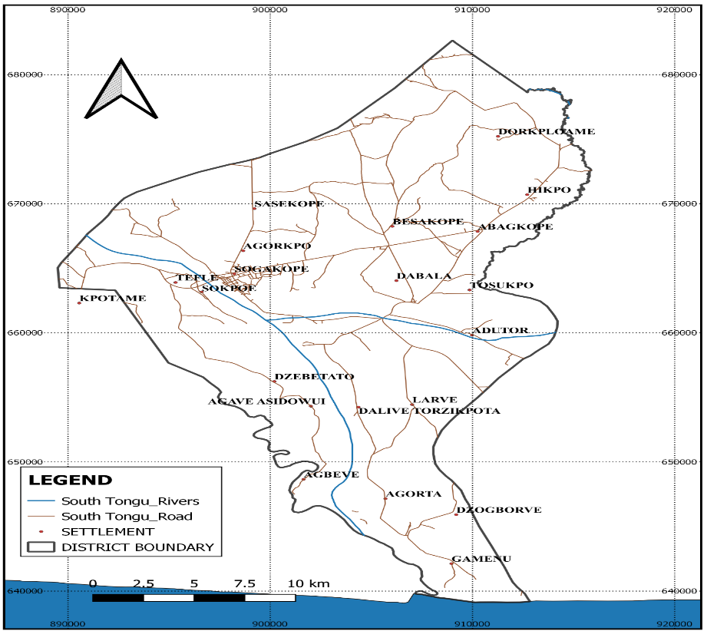
Physical access to services such as health, education, postal and telecommunication, agriculture extension, banking, police and marketing centres are mainly by road. The ECOWAS highway from Aflao passes through the Municipal to Tema. Untarred feeder roads link settlements in the Agave-Afedume and Larve Area Councils. However, some communities like Adutor, Avuto, Agbogbla and their surrounding villages are linked to Dabala (the commercial hub of the area) by a tarred feeder road of about 27km. Another tarred road of about 45km connects Dabala Junction in the South Tongu Municipal to Anloga in the Anloga Municipal. Most feeder roads become unmotorable during the rainy seasons, which hinder easy movement of people, goods and services, slow down economic activity and adversely affect people’s income. River transport is supported by the availability of a ferry, operated by the Ghana Highways Authority, which plies from Ada through South Tongu Municipal to Akuse on daily basis. There is a need to encourage this mode of transport as it provides the safest means of river transport across the Municipal. However, during strong winds and rainstorm, transportation by local canoes becomes dangerous. The figure below shows road networks within the Municipal. Figure 5: Road networks

1.10 Internal Revenue Generation
Internal revenue generation is considered as a critical focus area of the Municipal Assembly especially at this time where external inflows have reduced drastically. To improve internal revenue generation, the Municipal Assembly has prepared and implemented Revenue Improvement Action Plan (RIAP). As a result of the implementation of the revenue improvement action plan, there is a consistent modest improvement in total internal revenue generation over the period as shown in table 2 below.
Table 2: IGF performance (2018-2023)
Source of funds | Year 2018 (GH¢) | Year 2019 (GH¢) | Year 2020 (GH¢) | Year 2021 (GH¢) | Year 2022 (GH¢) | Year 2023  (GH¢)
Rates | 100,341.74 | 133,462.55 | 165,054.57 | 132,532.00 | 102,641.15 | 50,266.72
Fees | 190,506.55 | 186,393.73 | 197,255.25 | 240,896.26 | 246,805.85 | 209,632.40
Licenses | 161,645.14 | 196,128.76 | 158,719.09 | 227,893.60 | 258,223.00 | 287,229.50
Lands and Royalties | 76,258.96 | 101,352.80 | 82,152.00 | 102,680.00 | 138,543.00 | 391,797.80
Rents | 21,921.00 | 70,704.00 | 129,424.50 | 90,004.00 | 80,172.00 | 73,705.00
Fines, penalties and forfeits | 0.00 | 0.00 | 850.00 | 0.00 | 250.00 | 700.00
Miscellaneous | 6,002.98 | 16,621.00 | 5,734.53 | 2,700.00 | 5,524.18 | 6,935.40
Total | 556,676.37 | 704,662.84 | 739,189.94 | 796,705.86 | 832,159.18 | 1,020,266.82
Source: STDA Annual Financial Statements

1.11 Municipal Economy
a) Agriculture
As shown in figure 6 below, South Tongu Municipal is an agrarian Municipal where agriculture employs about 46.7 percent of the economically active population. The key agricultural sub-sectors include primary crops production, animal husbandry and fishery/aquaculture.
Under crop production, a high proportion of households (90.9%) are engaged in crop farming in the rural areas as compared to 73.6 percent in the urban areas. Major crops grown in the Municipal are cassava, beans, maize, rice, okro, pepper, groundnut, garden egg, sugarcane, tomatoes and sweet potato. Rice is cultivated commercially at Fievie and Kpenu. Pepper or chilli farming is a major agribusiness activity by farmers at Agbakope, Agbagorme, Hikpo, Sasekope, Dendo and Tsavanya. Farmers at Gbonorkope and Fievie have also taken up onion farming. It is also acknowledge that in terms of cattle population per square kilometers, South Tongu Municipal accounts for the highest nationally.
Figure 6: Agriculture potentials
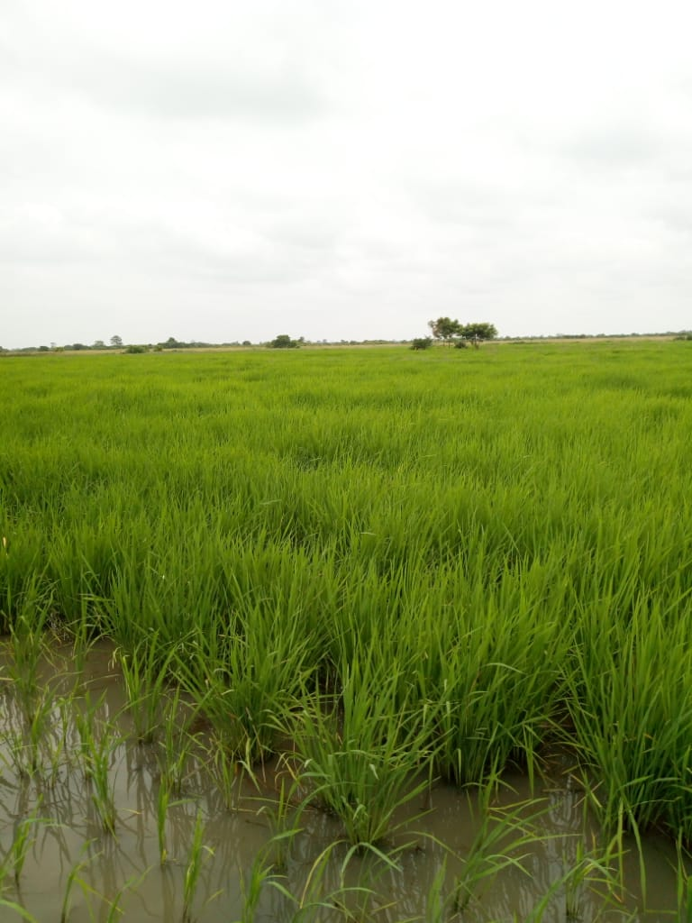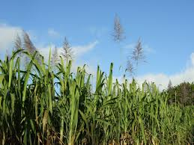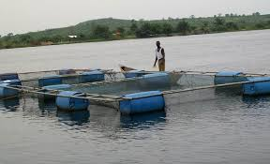
Rice farm Sugarcane farm Aquaculture
In the case of livestock rearing, the proportion of households engaged in this farming activity is higher in the urban areas than in rural localities. Major livestocks reared in the Municipal include chicken, cattle, goat, sheep, piggery, guinea fowl and duck. Cattle rearing dominates livestock activities in the Municipal, which may be due to absence of tsetse fly, short grasses and low rainfall pattern. Most of the animals are reared on subsistence basis except cattle, poultry and few others, which are undertaken for commercial purposes.
Fishing is of special interest because the Municipal is endowed with numerous water bodies including the Volta River, creeks and lagoons that support the fishing industry. The Volta River that flows through the Municipal is endow with tilapia and freshwater clam (Afoli) and other species of fish. Also, creeks and lagoons serve as good breeding grounds for tilapia, shrimps and mud fishes. Fish farming is undertaken at sections of the Volta River and harvested for sale to buyers within and outside (Accra, Keta and Aflao etc.) the Municipal. The data analysis by sex shows that the agriculture sector employs 53.9 percent males and 41.3 percent females.

b) Industry
The industrial/manufacturing sector of the Municipal employs close to 18.1 percent of the working population. The Municipal has a vibrant micro, small and medium scale industries which include cassava, fish and soyabeans processing, soap and detergent making, baking and confessionary, pottery, mat weaving, batik tie and dye, water purification and metal fabrication. The natural wild growing reeds, which is the main raw material for mat weaving, can also be explored through research and use in the production of toiletry products. A relatively high proportion of females (22.7%) than males (12.1%) engage in industrial and manufacturing sectors.
c) Service
Under the service category, there are managers, professionals, technicians, clerical and service, hospitality, financial services, transport services and sales workers. The service sector employs about 35.2 percent of the working population in the Municipal with 14.3 percent of the sector into wholesale, retail, repair of motor vehicles and motorcycles that might be due to the high commercial potential in the Municipal. It is interesting to note that there are a higher proportion of females (36.0%) in the service sector than males (34.0%).
d) Tourism
The South Tongu Municipal, which is strategically located, has virtually become the national hub for the hospitality industry. There are about 600 rooms available for hosting conferences, tour related activities and other recreational programmes across the Municipal. In addition, few islands like Tuanikope can be developed into riverside resorts to attract tourists. Along the creeks that flow into the Volta River are several waterfowls, including the pelicans near Agave-Afedume. The Avu Lagoon near Adutor is home to several birds and an endangered amphibian antelope called Sitatunga. The Lower Volta basin provides an ideal environment for eco-tourism to thrive. The Volta River continues to provide the right environment for the promotion of water sports and boost the hospitality industry in the Municipal. In addition, the Municipal is blessed with a clean sandy beach interspersed with coconut trees at Agorta, which naturally offers a place of relaxation to tourists. It is envisaged that the fortunes of the tourism industry could be enhanced through a deliberate policy of improving access to these facilities. Figure 7 below shows key tourist attractions in the Municipal.

Figure 7: Tourist attractions
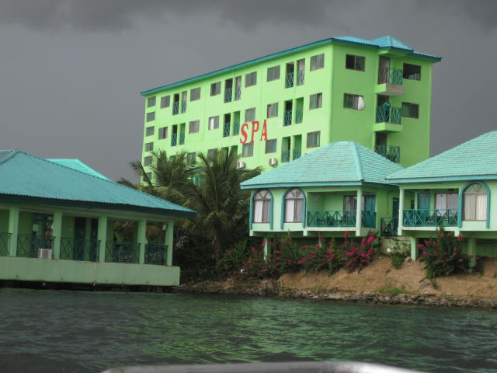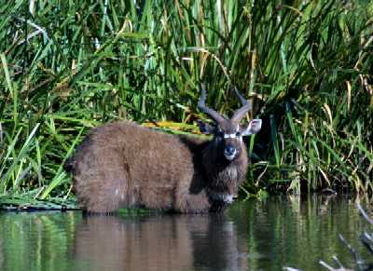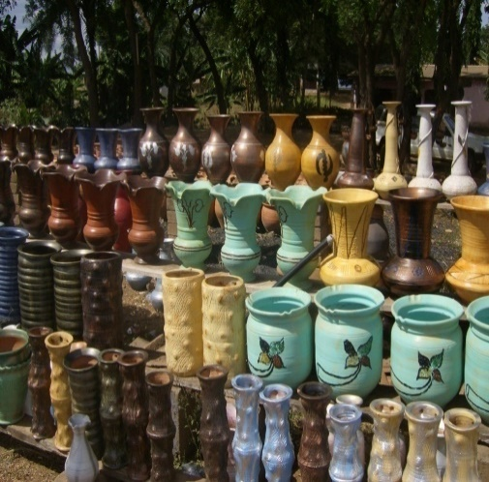
River front resorts Sitatunga Pottery

e) Business and Job Creation
The local enterprises contribute immensely to the development of the Municipal through provision of employment, food security and revenue. The Municipal Assembly supports training and rendering of business advisory services to local entrepreneurs and artisans in production improvement, product packaging, small business management and financial record keeping. Furthermore, the Municipal Assembly grants them land development and building permits and assist them to get financial support from MASLOC. Conditions of feeder roads need improvement to ease movement of goods and services to Sogakope, Dabala and other market centers in the Municipal. The table below shows the distribution of local enterprises within the Municipal.
Table 3: Distributions of local enterprises
Enterprises | Locations
Farm based Enterprises  a) Poultry rearing  b) Grassutter rearing  c) Beekeeping  d) Piggery  e) Fish farming  f) Vegetables (okro, tomatoes, carrot, pepper)  g) Maize, cassava and sweet potatoes farming  h) Sugarcane farming  i) Rice farming  j) Cattle rearing  k) Beans farming | -Sogakope, Kpotame, Sokpoe, Alavanyo, Amedormekope  -Dabala, Detsawome, Fieve, Sokpoe, Tenve & Kpotame  -Kasangblekpo, Morkordze  -Adutor, Kpotame, Dendo, Sokpoe  -Tadze, Sokpoe, Tuanikope  -Agbakope, Agbagorme, Dordoekope, Dzetorkoe, Torve, Hikpo, Sokpoe, Fievie-Dugame, Fievie-Kpodzi, Dendo, Dedo, Hlevi, Lakpo, Dorkploame, Besakope, Tordzinu, Tsavanya, Gonu  -Kpotame, Dendo, Dedo, Awuyakope, Agbeve, Hlevi & Atsieve, Agorhome, Besakope, Amedormekope, Dorklpoame, Gonu  -Tosukpo, Agbogbla, Adutor, Avuto, Amedormekope, Gonu  -Fieve, Agbakope, Dalive-Torzikpota, Akplorti, Hlevi, Avegorme, Bakpo, Lakpo, Besakope, Lakpo, Dorklpoame, Tordzinu & Kpenu  -Kua, Kpotame, Kasangblekpo, Kpordiwlor, Dzitsekope, Fievie-Kpodzi, Dendo, Dedo, Amedormekope, Tordzinu, Dorklpoame, Gonu  -Fievie-Dugame, Fievie-Kpodzi
Agro-processing Enterprises  a) Cassava processing  b) Fish processing  c) Soyabeans processing | -Dendo, Kpotame, Yorkutikpo, Akutukope, Agorgbe, Dedo  -Tadze, Gonu & Sokpoe  -Agbakope
Agro-industrial Enterprises  a) Soap and detergent making  b) Baking and confessionary | -Sogakope  -Sogakope, Sokpoe, Tefle & Dabala Junction
Traditional Craft Enterprises  a) Batik tie and dye  b) Mat weaving  c) Ceramics  d) Basket weaving | -Agorkpo, Dendo, Sogakope  -Detsawome, Gamenu, Galosota, Adutor, Lolito, Akutukope, Tadze, Atravenu, Nyinuto, Asidowui, Dedo, Amedorme, Gonu & Larve  -Vume & Tefle  -Avegoeme
Post Harvest Enterprises  a) Crop drying (pepper) | -Agbakope, Agbagorme, Hikpo, Sasekope, Dendo & Tsavanya
Fabrication  a) Screw press for cassava and palm oil processing, soap cutting machine, cassava greater | -Sogakope
Others  a) Hospitality facilities  b) Financial services  c) Stone, gravel & sand mining | -Sogakope, Agorkpo, Tefle, Sokpoe, Hikpo & Dabala  -Sogakope, Kpotame, Dabala & Agorkpo  -Bakpo, Toklokpo, Awuyakope, Lolito, Tefle, Sokpoe
Source: Field Survey, 2023

1.12 Natural Resource Endowment
The Municipal is blessed with natural resources such as rivers, lagoons, streams, arable lands, grazing fields, clay, and sand and gravel deposits. These resources can generally be grouped under mineral resources, arable land and water resources. The mineral resources are sand, gravel and clay which is mainly extracted for pottery using indigenous technologies. Modern mining techniques however can be used to enhance the utilization and extraction of the resources especially river sand. The arable and grazing lands are use for crop production and animal rearing. The available technologies for extracting these resources are basically indigenous, and improved farming methods like mechanization could enhance its extraction and utilization as well. The water resources available are the Volta River, River Tordzi, Angaw Lagoon, Avu Lagoon, Hlortor and many other creeks and lagoons which are used for fishing, farming and tourism. Traditional and aquaculture methods are used in exploiting these resources. In addition, pumping machinery would also enhance their extraction and utilization of these resources.
The effective utilization of these resources and provision of the needed support will go a long way to attract tourists, generate income and improve the general economic development of the local people. The major challenges facing the use of the natural resources are the poor accessibility, inadequate investment, poor land tenure system, bad farming, and aquaculture practices. By attaining a Municipal status, South Tongu Municipal would attract a wide range of investment opportunities that would go a long way to enhance the economic development of the Municipal and improve the living standard of the people.

1.13 Education
a) Distribution of educational facilities and service delivery
The Municipal has 350 educational institutions, which are public and privately owned. There are 130 Kindergartens, 127 Primary, 88 Junior High Schools, three (3) Senior High Schools, and two (2) Technical Vocational Institutes in the Municipal. The table below indicates number of public and private schools at each level of education.
Table 4: Number of public and private schools by level
Level | Public | Private | Total
KG | 89 | 41 | 130
Primary | 87 | 40 | 127
JHS | 67 | 21 | 88
SHS | 3 | 0 | 3
TVET | 2 | 0 | 2
TOTAL | 248 | 102 | 350
DED Annual Report, 2024
b) Students Enrollment and Teacher Distribution
Primary school level has the highest enrolment of students and untrained teachers whereas TVET level receives the lowest student enrolment and trained teachers as shown in table below.
Table 5: Student enrolment and teacher distribution
LEVEL | ENROLLMENT |  |  | TEACHERS
LEVEL | BOYS | GIRLS | TOTAL | TRAINED |  |  | UNTRAINED
 |  |  |  | M | F | TOTAL | M | F | TOTAL
KG | 3,614 | 3,536 | 7,150 | 23 | 163 | 185 | 3 | 47 | 50
Primary | 9,912 | 9,835 | 19,747 | 304 | 224 | 528 | 27 | 64 | 91
JHS | 3,970 | 3,825 | 7,795 | 325 | 116 | 441 | 39 | 32 | 71
SHS | 2,555 | 3,675 | 6,230 | 136 | 163 | 299 | 7 | 10 | 17
TVET | 1,573 | 776 | 2,349 | 31 | 18 | 49 | 4 | 2 | 6
TOTAL | 21,624 | 21,647 | 43,271 | 819 | 684 | 1,503 | 80 | 155 | 235
Source: DED Annual Report, 2024

1.14 Health
a) Distribution of Health Facilities and Service Delivery
The Municipal is divided into six (6) health sub-Municipals (Sogakope, Dorkploame, Sotevu, Dabala-Adutor, Dordoekope, Agorta-Gamenu) for the purposes of effective health service delivery and administration. Healthcare services are delivered at three (3) levels with the first level delivered at the CHPS compounds across the Municipal; the second level is delivered at the health centers/clinics in the Municipal and the third level is delivered at the hospitals in the Municipal.
The South Tongu Municipal occupies a unique location along the Trans West African highway and has two major hospitals (Municipal Hospital and Richard Novati Hospital). These hospitals have full-blown facilities to carry out major and critical healthcare services. The Municipal Hospital is being upgraded to host trauma center facilities to cater for emergencies that may occur through accidents along the highway. People from the Republic of Togo and individuals from neighboring Municipals also patronize the hospitals. Its elevation to Municipal Hospital will bring further investment and opportunities for growth that will benefit patrons from its catchment areas. The hospitals also serve as training center for medical students. It is also projected that two health centers (Dabala Health Center and Adutor Health Center) in the Municipal will soon be redesignated into polyclinics and additional facilities provided to further enhance medical care in the Municipal.
Table 6: Distribution of health facilities
Type | No. | Operator |  |  |  | Location
Type | No. | GHS | CHAG | PRIVATE | PPAG | Location
Hospital | 2 | 1 | 1 | 0 | 0 | Sogakope
Health Centre | 4 | 4 | 0 | 0 | 0 | Dordoekope, Kpotame, Adutor & Dabala
CHPS Compounds | 19 | 19 | 0 | 0 | 0 | Asidowui, Agbeve, Dzebetato, Tefle, Sokpoe, Sokutime, Agbakope, Larve, Gonu, Hikpo, Dalive, Tosukpo, Agorta, Dzogborve, Gamenu, Sogakope, Sasekope, Besakope, Dorkploame
Clinics | 3 | 0 | 0 | 2 | 1 | Sogakope & Akplale,
Total | 28 | 24 | 1 | 2 | 1
Source: DHD Report, 2024
b) Clinical Staff strength
Availability of doctors, nurses and midwives in attending to patients is very important in improving healthcare delivery in the Municipal. The table below shows the number of key health personnel available at the various health facilities in the Municipal to serve the population.
Table 7: Staff strength of key health professionals
Cadre of personnel | 2020 |  | 2021 |  | 2022 |  | 2023 |  | 2024
Cadre of personnel | No. | Patient ratio | No. | Patient ratio | No. | Patient ratio | No. | Patient ratio | No. | Patient ratio
Midwives | 68 | 1:1,624 | 93 | 1:1,293 | 103 | 1:1,121 | 103 | 1:1,206 | 109 | 1:1,076
Nurses | 293 | 1:406 | 496 | 1:214 | 501 | 1:238 | 434 | 1:286 | 351 | 1:334
Physician Assistants | 8 | 1:13,064 | 10 | 1:12,586 | 17 | 1:6,579 | 12 | 1:10,353 | 13 | 1:9,029
Doctors | 14 | 1:8004 | 18 | 1:6,308 | 21 | 1:5499 | 19 | 1:6,539 | 20 | 1:5,869
Source: DHD Report, 2024

1.15 Water and Sanitation
a) Water
Data in the table below on main source of potable water shows that, pipe born water account for 54.49 percent, followed by river/stream (13.18%). Rainwater (0.51%) forms the least used source of water by households. For the source of potable water by locality, Pipe born water is the most used in urban areas (59.31%) than in the rural areas (52.06%). Also, the use of River/Stream is predominant in rural areas (17.16%) than urban areas (5.26%). There is a need for continuous increase pipe born water coverage to reduce the risk of water-borne diseases and coverage of long distances to access potable water.
Table 8: Sources of water for household usage
Source of Water | Water usage by Households
Source of Water | Municipal (%) | Urban (%) | Rural (%)
River/Stream | 13.18 | 5.26 | 17.16
Pipe born | 54.49 | 59.31 | 52.06
Bore-hole/Pump/Tube well | 0.87 | 0.63 | 0.99
Rainwater | 0.51 | 0.18 | 0.68
Dugout/Pond/Lake/Dam/Canal | 2.02 | 0.28 | 2.89
Others (protected well & spring, bottled water, sachet water, tanker supply/vendor provided, unprotected well & spring) | 28.93 | 34.33 | 26.22
Source: GSS, 2021 PHC
b) Sanitation
Toilet Facilities
Following the improvement in potable water supply within the Municipal, flush toilets and other improved form of toilets have significantly reduced the practices of free range and use of pan toilet facilities. Also, the adoption and use of bio digester and biogas technology toilet facilities especially in urban communities have resulted in considerable improvement of sanitation in the Municipal. The table below supports the above assertion.
Table 9: Type of toilet facility used by households
Toilet facility | Facility usage by Households
Toilet facility | Municipal (%) | Urban (%) | Rural (%)
No facilities (bush/beach/field) | 24.59 | 6.30 | 33.81
Water Closet. | 13.23 | 24.64 | 7.48
Biodigester/Biogas | 3.02 | 4.34 | 2.35
Portable toilet | 0.04 | 0.09 | 0.01
Pit latrine | 23.15 | 21.65 | 23.89
KVIP | 18.59 | 25.65 | 15.03
Public toilet (WC/KVIP/PitPan etc) | 17.29 | 17.20 | 17.34
Bucket/Pan | 0.05 | 0.06 | 0.05
Other | 0.04 | 0.07 | 0.03
Source: GSS, 2021 PHC

CHAPTER TWO

2.0 Goals, Issues, Policy Objectives and Strategies

The goals, policy objectives and strategies outlined to address the prioritized development issue in the Municipal are summarize in table 33. The strategies adopted to address the development issues were informed by:
a) Financial considerations: that is how much it would cost to implement the strategy.
b) Available resources: Availability of staff (including technical expertise), money, and time to implement the strategy.
c) Target population: Acceptance of the strategy by the target population.
d) Social costs: Long-term positive and negative consequences of the strategy to the target population.
e) Intended objectives: check if the strategy will achieve the intended objectives
f) Technology: Will available technology promote the use of the strategy while assessing the ease of technology adoption by the target population.
Table 10: Goals, issues, policy objectives and strategies
Goal | Issue | Objective | Strategy
1. Build a prosperous society | 1. Revenue under performance due to leakages and loopholes, among others  2. Limited local participation in economic development  3a. High cost of production inputs  3b. Low application of technology especially among smallholder farmers leading to comparatively lower yields  4. Poor tourism infrastructure and service | Ensure improved fiscal performance and sustainability  Pursue strategic national industrial development initiatives  Create an enabling agribusiness environment  Modernize and enhance agricultural production systems  Diversify and expand the tourism industry for economic development | Strengthen revenue institutions and administration  Introduce industrial subcontracting exchange to link SMEs with large-scale enterprises  Ensure sector programmes and projects link smallholder and commercial producers to industry  Reinvigorate extension services  Promote local tourism and develop available and potential sites to meet international standards
2. Create opportunities for all | 2.1 Poor quality of education at all levels  2.2a Gaps in physical access to health infrastructure and services  2.2b Increasing morbidity, mortality, and disability due to communicable, non-communicable and emerging diseases  2.3a Increasing demand for household water supply  2.3b Poor attitude of citizenry towards the environmental sanitation  2.4 Increasing child rights violation  2.5 Inadequate and limited coverage of social protection | Enhance inclusive and equitable access to, and participation in quality education at all levels  Ensure affordable, equitable, accessible quality and universal health coverage (UHC) for all  Reduce disability, morbidity, and mortality  Improve access to safe and reliable sustainable water supply services for all  Enhance access to improved and sustainable environmental sanitation services  Prevent and protect children from all forms of violence, abuse, neglect and exploitation  Strengthen social protection for the vulnerable | Enhance quality of teaching and learning environment  Accelerate implementation of Community-based Health Planning and Services (CHPS) policy  Strengthen prevention and management of malaria cases.  Intensify and sustain immunization for all children under 2  Expand safe water production and distribution systems  Promote national total sanitation campaign  Increase community engagements and behavioural change campaigns to promote positive parenting attitudes and practices among parents and caregivers  Implement productive social inclusion interventions
3. Safeguard the natural environment and ensure a resilient built environment | 3.1 Over-exploitation and inefficient use of forest resources  3.2 Weak legal and policy frameworks for disaster prevention, preparedness and response  3.3a Rapid deterioration of roads  3.3b Limited safety facilities; poor services on inland waterways  3.4 Poor prioritization of Spatial Planning (Structure and Local Plans). | Promote sustainable use of forest and wildlife resources  Promote proactive planning for disaster prevention and mitigation  Improve efficiency and effectiveness of road transport infrastructure and services  Enhance the contribution of inland waterways to safe and efficient transportation of goods and people  Promote sustainable, spatially integrated and orderly development of human settlements | Promote and develop mechanisms for transparent governance, equity sharing and stakeholder participation in the forest, wildlife and wood fuel resource management  Educate public and private institutions on natural and man-made hazards and disaster risk reduction  Enhance maintenance and management practices for all transport sector  Promote the use of modern, safe, sustainable materials and technology in the construction of local boats and vessel  Ensure preparation of Spatial Development Frameworks, Structure Plans and Local Plans for MMDAs
4. Maintain a stable, united and safe society | 4.1 Ineffective sub-Municipal structures  4.2 Weak involvement and participation of citizenry in planning and budgeting | Deepen political and administrative decentralization  Improve popular participation at regional and Municipal levels | Strengthen sub-Municipal structures  Promote effective stakeholder involvement in development planning process, local democracy and accountability  Improve service delivery at MMDA level
5. Improve emergency preparedness and response planning | 5.1 Limited Institutional Capacities | Enhance institutional capacity and coordination for effective emergency response | Institute measures for experience sharing on emergency response and capacity building
6. Strengthen coordination, monitoring and evaluation | 6.1 Inadequate logistics  6.2 Inadequate financial, logistics and human resources | Strengthen plan preparation, implementation and coordination at all levels  Strengthen monitoring and evaluation systems at all levels | Strengthen and improve resource mobilisation for plan implementation  Strengthen M&E capacities at all levels
Source: DPCU, 2024

CHAPTER THREE

3.0 COMPOSITE ANNUAL ACTION PLAN (2025)
This Activity Plan is based on the Development programme formulated for the achievement of specific policy outcomes in 2025. This constitutes those projects or activities, to be implemented in the 2025 as part of the continuous efforts to achieve the broader goal of the Municipal Medium Term Development Plan 2022-2025. Its detailed activities are categorized under the various Development Dimensions of the National Development Policy Framework, an Agenda for Jobs 2022-2025.

Activities (Operations | Location | Baseline | Output Indicators | Timeframe |  |  |  | Cost (GH¢) |  |  | Programme status |  | Implementing institution/depart.
 |  |  |  | Q1 | Q2 | Q3 | Q4 | GoG | IGF | DPs | New | On-going | Lead | Collaborating

Development Dimension: Governance, Corruption and Public Accountability

Programmes (PBB): Management and administration

Sub-programmes (PBB): General administration
Provide needed funds for 4No. Area Councils to maintain their offices, procure equipment/consumables, conduct quarterly meetings, sensitisation programmes and development projects. | Sogakope, Dabala, Larve & Agave-Afedume | Inadequate logistics | All the Area Councils supported |  |  |  |  | 110,000 | 50,000 |  | √ |  | DE/PO | Central Adm./Area Councils
Organise town hall & stakeholders’ meetings on government policies & assembly activities | Sogakope, Dabala, Larve & Asidowui | Routine activity | Town hall & stakeholders’ meetings  organised |  |  |  |  | 15,000 | 35,000 |  | √ |  | DPO/DBA | DCD/HoDs
Mobilise & engage communities on development issues affecting them | Selected towns | Limited participation of people in development issues | Number of community meetings conducted |  |  |  |  | 15,000 | 5,000 |  | √ |  | DPO/DBA | DCD/HoDs
Procure & service office equipment, logistics, stationery, consumables, protocol services and others for departments of the Municipal assembly | Sogakope | Routine activity | Logistics provided for all department |  |  |  |  | 150,000 | 80,000 |  | √ |  | PO | DCD/HoDs
Maintain Municipal assembly office assets, equipment, machines, furniture & fittings | Sogakope | Assembly assets equipment, machines, furniture & fittings not in good condition | Assembly office assets, equipment, machines, furniture & fittings maintained |  |  |  |  | 200,000 | 80,000 |  | √ |  | DE | DCD/HoDs
Complete Municipal Assembly office block (Phase II) | Sogakope | Inadequate office space | Assembly office block completed |  |  |  |  | 500,000 |  |  | √ |  | DE/PO | DCD/HoDs
Utilize MP's common fund on building materials, laboratory equipment, jerseys & footballs, mathematical sets, pumping machines etc. to support selected communities | Selected towns | Routine activity | MP's common fund utilized |  |  |  |  | 300,000 |  |  | √ |  | MP | Central Adm.
Support self-help/community-initiated projects | Selected towns | Routine activity | self-help/community-initiated projects supported |  |  |  |  | 150,000 |  |  |  | √ | DE/PO | Central Adm. Assembly members
Renovate Dabala Municipal Court | Dabala | The court in bad condition | Dabala Municipal Court renovated |  |  |  |  | 50,000 |  |  |  | √ | DE | DCD/HoDs
Renovate deplorable Municipal assembly residential buildings | Sogakope | Some Assembly residential buildings in a deplorable state | Deplorable Municipal assembly residential buildings renovated |  |  |  |  | 150,000 |  |  | √ |  | DE | DCD/HoDs

Sub-programmes (PBB): Finance and revenue mobilization
Supervise revenue collectors and, procure logistics for revenue collection. | Sogakope, Dabala & other towns | Routine activity | Revenue collectors supervised and property and business data collected |  |  |  |  |  | 10,000 |  | √ |  | DFO | Revenue collectors
Conduct data collection on property and businesses in the Municipal | Entire Municipal | property and businesses register outdated | Property and business data collected |  |  |  |  | 25,000.00 |  |  | √ |  | DPCU | Finance department
Carry out tax education & create awareness on fee-fixing resolution for SMEs & other stakeholders | Sogakope, Dabala & other towns | Low awareness by SMEs on tax payment obligations | Tax education & awareness creation on fee fixing conducted |  |  |  |  | 5,000 | 5,000 |  | √ |  | DBA/DFO | DCD/HoDs

Sub-programmes (PBB): Planning, budgeting, and coordination
Prepare & submit annual action plan, NACAP, RIAP, Composite Budget & other reports of the assembly | Sogakope | Routine activity | Annual action plan, RIAP, composite budget & other reports of the assembly Prepared & submitted |  |  |  |  | 20,000 | 15,000 |  | √ |  | DPO/DBA | HoDs
Undertake participatory supervision, monitoring, evaluation & auditing of development projects & programmes | Selected towns | Routine activity | Participatory supervision, monitoring, evaluation & auditing of development projects & programmes |  |  |  |  | 30,000 | 20,000 |  | √ |  | DPO/DE | HoDs
Prepare and submit 2026-2029 Medium Term Development Plan | Entire Municipal | 2022-2025DMTDP ends in 2025 | 2026-2029 Medium Term Development Plan prepared and submitted |  |  |  |  | 80,000.00 |  | 20,000.00 | √ |  | STDA | NGOs/CSOs/DPs
Collect, compile, validate, analyse, store, disseminate and submit 2025 quarterly Administrative Data | Sogakope | Routine activity | Administrative Data collected and submitted |  |  |  |  | 500.00 | 500.00 | 1,000.00 |  |  | Statistical Department | Head of Departments/Units, Assembly members
Collaborate with GSS to collect, compile and submit 2025 monthly data on open market price statistics | Akatsi, Sogakope | Routine activity | monthly data on open market price statistics compiled |  |  |  |  | 3,500.00 | 500.00 | 800.00 |  |  | Statistical Department | GSS, market and shop owners
Update the Municipal Development Data Platform quarterly | Sogakope | Routine activity | DDDP System updated quarterly |  |  |  |  | 500.00 | 200.00 | 500.00 |  |  | Statistical Department /Planning Unit | Head of Departments/Units, Assembly members
Educate/Sensitize the public on surveys in collaboration with GSS and NCCE | Municipal wide | Routine activity | Education/Sensitization of public on surveys conducted |  |  |  |  | 1,000.00 | 500.00 | 1,000.00 |  |  | Statistical Department | NCCE, GSS

Sub-programmes (PBB): Legislative oversights
Organize general assembly, sub-committee, tender committee, management, street address team, audit committee & other meetings | Sogakope | Routine activity | general assembly, sub-committee, tender committee, management, street address team, audit committee & other meetings conducted |  |  |  |  | 20,000 | 90,000 |  | √ |  | Central Adm. | HoDs
Sensitise assembly & unit committee members on their roles, functions & bye laws | Sogakope & Dabala | Inadequate skills by assembly & unit committee members on their roles, functions & bye laws | Assembly & unit committee members on their roles, functions & bye laws sensitised |  |  |  |  |  | 5,000 |  | √ |  | NCCE | Central Adm./DFO

Activities (Operations | Location | Baseline | Output Indicators | Timeframe |  |  |  | Cost (GH¢) |  |  | Programme status |  | Implementing institution/depart.
 |  |  |  | Q1 | Q2 | Q3 | Q4 | GoG | IGF | DPs | New | On-going | Lead | Collaborating

Development Dimension: Governance, Corruption and Public Accountability

Programmes (PBB): Management and administration

Sub-programmes (PBB): General administration
Monitor sanitation activities & collect data on water and sanitation facilities | Sogakope, Dabala & others | Routine activity | Sanitation activities monitored & data on roads, building projects, water and sanitation facilities collected |  |  |  |  | 5,000 | 5,000 |  | √ |  | DE | DCD/HoDs/Assembly members
Construct 2No. Public Pounds | Selected Area Councils | Inadequate Public Pounds | 2No. Public Pounds constructed |  |  |  |  | 20,000 |  |  | √ |  | DE/PO | DCD/HoDs/Area Councils
Acquire land for solid and liquid waste disposal | Hlevi | Inadequate land for solid and liquid waste disposal | Land for solid and liquid waste disposal acquired |  |  |  |  | 90,000 | 10,000 |  | √ |  | PPO/DEHO | Chiefs/Assembly members
Carry out solid waste management & maintain landfill site | Hlevi | Routine activity | Solid waste management & maintain landfill site carried out |  |  |  |  | 200,000 |  |  | √ |  | DEHO | DCD/HoDs/Zoomlion
Carry out liquid waste management & disinfect public places | Sogakope & Dabala | Routine activity | public/institutional toilets dislodged & disinfection exercise carried out |  |  |  |  | 80,000 | 10,000 |  | √ |  | DEHO | DCD/HoDs
Procure sanitation equipment & cleaning consumables | Sogakope | Routine activity | sanitation equipment & cleaning consumables procured |  |  |  |  | 50,000 | 10,000 |  | √ |  | PO | DCD/HoDs
Supervise cleaning of public places/observe sanitation day & air pollution | Sogakope & Dabala | Routine activity | Cleaning of public places/observe sanitation day supervised |  |  |  |  | 5,000 | 5,000 |  | √ |  | DEHU | DCD/Assembly members
Educate communities and households on hygiene, sanitation, noise & air pollution |  |  | Communities and households educated on hygiene, sanitation, noise & air pollution |  |  |  |  | 3,000.00 | 2,000.00 |  | √ |  | DEHU | DCD/Assembly members
Undertake food hygiene & conduct medical screening for food & water vendors | Sogakope, Dabala, Larve & Asidowui | Routine activity | food hygiene & medical screening for food & water vendors food & water vendors conducted |  |  |  |  |  | 5,000 |  | √ |  | DEHO | DCD/Assembly members

Activities (Operations | Location | Baseline | Output Indicators | Timeframe |  |  |  | Cost (GH¢) |  |  | Programme status |  | Implementing institution/depart.
 |  |  |  | Q1 | Q2 | Q3 | Q4 | GoG | IGF | DPs | New | On-going | Lead | Collaborating

Social Development

Programmes (PBB): Social services delivery

Sub-programmes (PBB): Social welfare and community development
Educate public, PTAs & school children on teenage pregnancy, girl child education week celebration & child marriage | Tosukpo & Agbobla | Increase in number of teenage pregnancy & child related issues. | public, PTAs & school children educated on teenage pregnancy related issues |  |  |  |  | 5,000 | 5,000 |  | √ |  | GES/GHS/  NYA/  SWCD | Central Adm.
Educate public on child abuse & trafficking | Selected towns | Routine activity | public educated on child abuse & trafficking |  |  |  |  | 5,000 | 5,000 | 60,000 | √ |  | SWCD | NGOs
Register and pay the aged and vulnerable under the LEAP programme | Selected towns | Routine activity | Beneficiaries of LEAP programme 3 Registered and paid |  |  |  |  | 5,000 | 5,000 |  | √ |  | SWCD | Central Adm.
Undertake Reassessment of LEAP Programme in the Municipal | All communities under LEAP project | Lack of data on the update of LEAP beneficiaries | Reassessment of LEAP Programme in the Municipal con |  |  |  |  | 10,000  .00 | 15,000  .00 |  | √ |  | SWCD | Central Adm.
Undertake care reform initiatives, streetism, repatriation & family welfare services | Sogakope | Increase in number of streetism | Care reform initiatives, streetism, repatriation & family welfare services impleted |  |  |  |  | 10,000 | 5,000 | 16,830 | √ |  | SWCD | Central Adm./NGOs
Carry out juvenile justice administration & supervise NGOs | Sogakope | Routine activity | Juvenile justice administration carried out & NGOs supervised |  |  |  |  | 5,000 | 5,000 |  | √ |  | SWCD | Central Adm.
Support Ghana school feeding programme in the Municipal | Sogakope | Routine activity | Ghana school feeding programme in the Municipal supported |  |  |  |  |  | 4,000 |  | √ |  | Desk officer | Beneficiary schools
Support persons with disability to acquire gainful employment, education & assistive devices | Sogakope | Persons with disability not gainful employ | Persons with disability supported to acquire gainful employment, education & assistive devices |  |  |  |  | 160,000 |  |  | √ |  | SWCD | Central Adm.
Activities (Operations | Location | Baseline | Output Indicators | Timeframe |  |  |  | Cost (GH¢) |  |  | Programme status |  | Implementing institution/depart.
 |  |  |  | Q1 | Q2 | Q3 | Q4 | GoG | IGF | DPs | New | On-going | Lead | Collaborating

Social Development

Programmes (PBB): Social services delivery

Sub-programmes (PBB): Education and youth development
Give financial support for brilliant but needy students | Sogakope | Routine activity |  |  |  |  |  | 160,000 |  |  | √ |  | Central Adm. | MP/GES
Supervise school feeding programme | School towns | Routine activity | Education programmes supervised & conducted |  |  |  |  |  | 5,000 |  | √ |  | GES | DCE/DCD  /HoDs
Support mock examinations & BECE for JHS 3 pupils | Entire Municipal | Routine activity | Mock examinations & BECE for JHS 3 pupils conducted |  |  |  |  | 25,000 |  |  | √ |  | GES | DCE/DCD/  HoDs
Support sports, culture & my first day programmes at basic schools in the Municipal | Sogakope | Routine activity | Sports, culture & my first day programmes at basic schools in the Municipal supported |  |  |  |  | 30,000 | 5,000 |  | √ |  | GES | DCE/DCD/HoDs
Support STMIE clinic, scholarships, best teacher award scheme | Sogakope | Routine activity | STMIE clinic, scholarships, best teacher award scheme & Independence Day anniversary celebration at Sogakope supported |  |  |  |  | 50,000 |  |  | √ |  | GES | DCE/DCD/HoDs
Conduct Independence Day anniversary celebration | Sogakope | Routine activity | Independence Day anniversary celebration conducted |  |  |  |  | 50,000.00 |  |  | √ |  | GES | DCE/DCD/HoDs
Complete 1No. 3-unit classroom block with ancillary facilities | Atsieve D/A Basic Schools | Limited number of classrooms | 2No. 3-unit classroom block with ancillary facilities completed |  |  |  |  | 323,318.10 |  |  |  | √ | DE | DCD/HoDs
Complete 1No. 3-unit classroom block with ancillary facilities | Hlevi | Limited number of classrooms | 2No. 3-unit classroom block with ancillary facilities completed |  |  |  |  | 493,618.00 |  |  |  | √ | DE | DCD/HoDs
Renovation of 1No. 4-unit classroom | Dordoekope D/A JHS | Classrooms in bad condition | 1No. 4-unit classroom renovated |  |  |  |  | 73,000 |  |  |  | √ | DE | DCD/HoDs
Re-roof/renovate 1No. 3-unit classroom block with ancillary facilities | Dendo D/A Basic School | Classrooms in bad condition | 1No. 3-unit classroom block with ancillary facilities renovated |  |  |  |  | 70,000 |  |  |  | √ | DE | DCD/HoDs
Re-roof 2No. 3-unit classroom block with ancillary facilities | Dzebetato D/A Basic School | Classrooms in bad condition | 1No. 3-unit classroom block with ancillary facilities renovated |  |  |  |  | 170,000 |  |  |  | √ | DE | DCD/HoDs
Construct 1No. 3-unit classroom block with Staff Common room, Office, 1NO. 4-Unit Water Closet Seater and plant 50NO. Economic trees around the facility | Sogakope Technical Institute | Limited number of classrooms | 1No. 3-unit classroom block with ancillary facilities constructed |  |  |  |  |  |  | 620,000 | √ |  | DE | DCD/HoDs
Complete 1No. 3-unit classroom block with ancillary facilities | Kua D/A Basic School | Limited number of classrooms | 1No. 3-unit classroom block with ancillary facilities completed |  |  |  |  | 30,000 |  |  |  | √ | DE | DCD/HoDs
Procure & distribute 400 pieces of mono desks, 700 pieces of dual desks, 30 pieces of teachers tables and 60 pieces of teachers chairs for JHSs, Primary Schools and Teacher respectively | Selected schools | Inadequate furniture for smooth learning and teaching | 400 pieces of mono desks, 700 pieces of dual desks, 30 pieces of teachers tables and 60 pieces of teachers chairs for JHSs, Primary Schools and Teacher respectively procured & distributed |  |  |  |  |  |  | 605,306.00 | √ |  | Central Adm. | GES
Support organisation of youth parliament for 35 youth & train 20 youth in leadership skills | Sogakope | Routine activity | youth parliament for 35 youth & train 20 youth in leadership skills supported |  |  |  |  | 5,000 | 5,000 |  | √ |  | NYA | Central Adm.

Activities (Operations | Location | Baseline | Output Indicators | Timeframe |  |  |  | Cost (GH¢) |  |  | Programme status |  | Implementing institution/depart.
 |  |  |  | Q1 | Q2 | Q3 | Q4 | GoG | IGF | DPs | New | On-going | Lead | Collaborating

Social Development

Programmes (PBB): Social services delivery

Sub-programmes (PBB): Health delivery
Support immunization & malaria control programmes in the Municipal | Sogakope & other towns | Routine activity | Immunization & malaria control programmes in the Municipal supported |  |  |  |  | 45,000 | 10,000 |  | √ |  | GHS | Central Adm.
Carry out disease surveillance & public health outreach programmes | Selected towns | Routine activity | disease surveillance & public health outreach programmes conducted |  |  |  |  | 10,000 | 5,000 |  | √ |  | GHS | Central Adm.
Celebrate World AIDs Day & support HIV/AIDs prevention/response programmes in the Municipal | Sogakope & other towns | Routine activity | World AIDs Day celebrated & HIV/AIDs prevention/response programmes in the Municipal supported |  |  |  |  | 20,000 |  |  | √ |  | GHS/NYA | STDA
Construct 1No. CHPS Compound with ancillary facilities | Agorgbe | Lack of Health facility | 1No. CHPS Compound constructed |  |  |  |  |  |  | 750,000 | √ |  | DE | DCD/GHS
Complete 1NO. 2-Semi-detached self-Contain Nurses’ quarters, connect the facility to national grid and plant 25NO. Economic trees around the facility | Sogakope | Lack of nurses’ quarters | 1NO. 2-Semi-detached self-Contain Nurses’ quarters constructed and connected to electricity with 25NO. economic trees planted |  |  |  |  |  |  | 53,306 | √ |  | DE | DCD/DHS

Activities (Operations | Location | Baseline | Output Indicators | Timeframe |  |  |  | Cost (GH¢) |  |  | Programme status |  | Implementing institution/depart.
 |  |  |  | Q1 | Q2 | Q3 | Q4 | GoG | IGF | DPs | New | On-going | Lead | Collaborating

Development Dimension: Environment, Infrastructure and Human Settlements

Programmes (PBB): Infrastructure delivery and management

Sub-programmes (PBB): Physical and spatial planning
Monitor land development activities & educate public on spatial/building permit acquisition | Sogakope, Dabala & other towns | Routine activity | Land development activities monitored & public educated on spatial/building permit acquisition |  |  |  |  |  | 15,000 |  | √ |  | PPD | DCD/HoDs
Prepare spatial development framework, structure & local plans | Vume, Tademe, Agorkpo & others | No Prepare spatial development framework the Municipal & limited coverage of structure & local plans | spatial development framework, structure & local plans prepared |  |  |  |  | 296,000 | 12,000 |  |  | √ | PPD | GIZ/DCD/HoDs
Maintain/erect street signages | Adutor, Vume & Tademe | Routine activity | signages maintained |  |  |  |  | 10,000 | 10,000 |  |  | √ | PPD | GIZ/DCD/HoDs
Continue street naming & property addressing exercise | Adutor, Vume & Tademe | Routine activity | Street naming & property addressing exercise conducted |  |  |  |  | 20,000.00 | 10,000.00 |  |  | √ | PPD | GIZ/DCD/HoDs
Carry out landscaping & beautification exercise | Sogakope & Municipal assembly premises | Routine activity | landscaping & beautification exercise carried out |  |  |  |  | 40,000 |  |  | √ |  | PPD | DCD/HoDs

Activities (Operations | Location | Baseline | Output Indicators | Timeframe |  |  |  | Cost (GH¢) |  |  | Programme status |  | Implementing institution/depart.
 |  |  |  | Q1 | Q2 | Q3 | Q4 | GoG | IGF | DPs | New | On-going | Lead | Collaborating

Development Dimension: Environment, Infrastructure and Human Settlements

Programmes (PBB): Infrastructure delivery and management

Sub-programmes (PBB): Infrastructure development
Reshape 30.0km deplorable feeder roads | Selected towns | 50% of the feeder roads in bad condition with broken culverts | 3.0km deplorable feeder roads, access roads & construct culverts maintained |  |  |  |  | 150,000 |  |  | √ |  | DE | DCD/HoDs
Opening of 20km access roads in Sogakope Township and other major towns in the Municipal | Entire Municipal | 80% of access roads in Sogakope Township and other major towns in the Municipal are bad shape | 20km access roads in Sogakope Township and other major towns in the Municipal opened |  |  |  |  | 150,000.00 |  |  | √ |  | DE | DCD/HoDs
Construct 4NO. culverts in the Municipal | Selected areas | 4No. culnerts |  |  |  |  |  | 800,00 |  |  | √ |  | DE | DCD/HoDs
Erect/maintain road signages & construct speed rumps | Selected roads | Limited signages & speed rumps | road signages & construct speed rumps maintained |  |  |  |  | 50,000 |  |  | √ |  | DE | DCD/GHA
Educate drivers, motorists & public on road safety measures | Sogakope & other towns | Limited knowledge on road safety measures by motorists | drivers, motorists & public on road safety measures educated |  |  |  |  | 5,000 | 5,000 |  | √ |  | MTTD | DISEC
Provide 5No. canoes for crossing streams & rivers (MP Fund) | Selected towns | Limited number of canoes for crossing passengers | 10No. canoes for crossing streams & rivers procured |  |  |  |  | 50,000 |  |  | √ |  | PO | Central Adm./MP
Extend electricity to completed projects | Selected towns & institutions | 50% of completed projects have not connected to national grid | electricity extended to completed projects |  |  |  |  | 60,000 |  |  | √ |  | DE | Central Adm./ECG
Provide & maintain 200No. streetlights | Selected towns | Routine activity | 300No. streetlights provided & maintained |  |  |  |  | 100,000 |  |  | √ |  | DE | Central Adm./ECG/MP
Construct 2No. 8-Unit Open Sheds at Dabala Market | Dabala Markets | Limited Open Sheds at Dabala Market | 1No. Open Sheds at Dabala Market constructed |  |  |  |  |  |  | 419,000 | √ |  | DE | DCD/HoDs
Fixing of 5No. metal gates and ancillary works at Sogakope market and rehabilitation of Dabala Market | Sogakope & Dabala | Market facilities in in a deplorable state | Market facilities fixed |  |  |  |  | 114,000 |  |  |  | √ | DE | DCD/HoDs

Activities (Operations | Location | Baseline | Output Indicators | Timeframe |  |  |  | Cost (GH¢) |  |  | Programme status |  | Implementing institution/depart.
 |  |  |  | Q1 | Q2 | Q3 | Q4 | GoG | IGF | DPs | New | On-going | Lead | Collaborating

Economic Development

Sub-programmes (PBB): Natural resource conservation
Provide business counselling and training programmes to SMEs in the Municipal | Municipal Wide | Routine Activity | Business counselling and training programmes conducted |  |  |  |  | 10,000 | 2,000 |  |  |  | BAC | Central Adm.
Provide Start-up kits to SMEs in the Municipal | Selected Beneficiaries | Routine Activity | Start-up kits to SMEs provided |  |  |  |  | 30,000.00 | 8,000.00 |  |  |  | BAC | Central Admin
Organize trade and investment show and promote tourism potentials in the Municipal | Ho | Routine Activity | Trade and investment show and promote tourism potentials in the Municipal organized |  |  |  |  | 20,000 | 5,000 |  |  |  | BAC | Central Adm.
Stakeholder Engagement with SMEs/Business Community | Sogakope | Routine Activity | SME issues/challenges identified and addressed |  |  |  |  | 3,000.00 | 1,000.00 |  |  |  | BAC | Central Admin
Local Economic Development (LED) Committee Sitting | Sogakope | Routine Activity | LED Priorities Identified |  |  |  |  | 6,000.00 | 2,000.00 |  |  |  | BAC | Central Admin
Local Businesses Association (LBA) Formation/Advocacy | Municipal Wide | Routine Activity | LBAs Formation |  |  |  |  |  |  | 10,000.00 |  |  | BAC | Central Admin

Activities (Operations | Location | Baseline | Output Indicators | Timeframe |  |  |  | Cost (GH¢) |  |  | Programme status |  | Implementing institution/depart.
 |  |  |  | Q1 | Q2 | Q3 | Q4 | GoG | IGF | DPs | New | On-going | Lead | Collaborating

Economic Development

Programmes (PBB): Economic development

Sub-programmes (PBB): Agricultural development
Organize farmers’ day anniversary | Selected towns | Routine activity | farmers’ day anniversary organized |  |  |  |  | 80,000 |  |  | √ |  | DAD | Central Adm.
Hold farmer fora to review performance of crops | Selected towns | Routine activity | Hold farmer fora to review performance of crops held |  |  |  |  | 3,500 | 5,000 | 4,200 | √ |  | DAD | Farmers
Establish demonstration farms on maize and rice | Selected towns | Routine activity | Demonstration farms on maize and rice 3 established |  |  |  |  |  | 5,000 | 3,500 | √ |  | DAD | Farmers
Train women in cassava and ginger processing | Hikpo, Kpodziadzi, Dendo, Sogakope Kpotame and Adutor | women in cassava and ginger processing have limited skills | women in cassava and ginger processing trained |  |  |  |  |  | 5,000 | 5,500 | √ |  | DAD | Women groups
Carry out home and farm visit to educate farmers on new farming methods | Selected towns | Routine activity | Home and farm visit to educate farmers on new farming methods conduted |  |  |  |  | 4,300 |  | 6,800 | √ |  | DAD | Farmers
Educate farmers on adaptation of early maturing crops, mulching, alterative livelihoods | Atitekpo, Detsaome, Tefle, Dordoekope and Dabala | Routine activity | farmers educated on adaptation of early maturing crops, mulching, alterative livelihoods |  |  |  |  | 5,800 |  | 4,300 | √ |  | DAD | Farmers
Activities (Operations | Location | Baseline | Output Indicators | Timeframe |  |  |  | Cost (GH¢) |  |  | Programme status |  | Implementing institution/depart.
 |  |  |  | Q1 | Q2 | Q3 | Q4 | GoG | IGF | DPs | New | On-going | Lead | Collaborating

Programmes (PBB): Environmental and sanitation management

Sub-programmes (PBB): Disaster prevention and management
Educate public on climate change adaption, disaster risks reduction & mitigation measures (rainstorm, windstorm, sand wining, deforestation, bush fire, flooding) | Atsieve, Kpotame, Dordoekope, Agbogbla, Larve & other towns | Frequent disasters cases | Public educated on climate change adaption, disaster risks reduction & mitigation measures |  |  |  |  | 5,000 | 8,000 |  | √ |  | NADMO | STDA/NCCE/GNFS
Support disaster management & provide relief items to affected communities | Affected towns | Routine activity | Disaster management supported & relief items to affected provided |  |  |  |  | 80,000 |  |  | √ |  | NADMO | Central Adm.
Build capacity & monitor disaster volunteer groups | Selected towns | Limited understanding of disaster issues by volunteer groups | Disaster volunteer groups trained |  |  |  |  | 5,000 | 6,500 |  | √ |  | NADMO | Central Adm.
Map disaster hazard areas & collect data on disaster activities | Selected towns | Limited data Disaster hazard areas | Disaster hazard areas mapped & data collected on disaster activities |  |  |  |  |  | 3,000 |  | √ |  | NADMO | PPD
Train staff on rapid rescue response & management of water related disasters | Sogakope | Limited skills on rapid rescue response & management of water related disasters | Staff trained on rapid rescue response & management of water related disasters |  |  |  |  |  | 3,400 |  | √ |  | NADMO | GNFS/GAF

Activities (Operations | Location | Baseline | Output Indicators | Timeframe |  |  |  | Cost (GH¢) |  |  | Programme status |  | Implementing institution/depart.
 |  |  |  | Q1 | Q2 | Q3 | Q4 | GoG | IGF | DPs | New | On-going | Lead | Collaborating

Programmes (PBB): Environmental and sanitation management

Sub-programmes (PBB): Natural resource conservation
Raise 20,000 seedlings, distribute them & carry out tree planting | Selected towns | Rampant depletion of vegetation | 20,000 seedlings raised & distributed for planting |  |  |  |  | 10,000 | 5,000 |  | √ |  | Forestry | Central Adm.
Support the activities of Avu Lagoon and Dusornu CREMA projects. | All communities under Avu Lagoon and Dusornu CREMA | Destruction of natural environment and wildlife | Activities of Avu Lagoon and Dusornu CREMA projects supported. |  |  |  |  | 10,000.00 | 10,000.00 |  | √ |  | Central Adm. | Avu Lagoon and Dusornu CREMA
Form green club in schools & promote woodlot development | Selected basic schools | Low awareness of promotion of woodlot development | green club in schools & promote woodlot development formed |  |  |  |  | 10,000 | 5,000 |  | √ |  | Forestry | NGOs/Central Adm.

CHAPTER FOUR

4.0 MONITORING AND EVALUATION

4.1 Introduction
The effectiveness of policies, programmes and projects are achieved through effective processes of monitoring and evaluation. Monitoring and Evaluation are to assist in the effective implementation of a plan/ programme/ project, and identify lessons that may be useful for future projects. The monitoring and evaluation of these projects will be done via the use of municipality monitoring systems or by the Municipal Assembly and the various stakeholders who would sponsor. This will help ensure that input delivery, work schedule and expected output matches the details of the plan.
The Municipal Assembly will facilitate the implementation of the plan. The essential actions needed to ensure effective implementation will include but not limited to the following:
- Maintenance of security, peace and public order in the entire municipality
- Co-ordination of planned programmes and projects of the various units (i.e. Area Councils, Decentralized Departments / Agencies, CSOs and the Private Sector)
- Strict adherence to execution of planned development programmes
- Strengthening of the Area Councils and unit committees to undertake community development initiatives.
- Promotion of justice, human rights and civil liberties
- Promote public education in civil rights and obligations.
- Organization of an efficient system of revenue mobilization
- Promote co-operation and coordination among public and private agencies involved in socio-economic development

4.2 Monitoring and Evaluation Arrangements
Monitoring and evaluation of projects and programmes within the planned period will be mainly undertaking by the Municipal Planning Co-ordinating Unit (DPCU), stakeholders and the communities.
Monitoring and evaluation reports of projects and programmes will be completed according to the formats provided by the National Development Planning Commission (NDPC), as indicated in the later parts of this chapter. Summaries of the reports will be made available for the Executive Committee (EXECO) of the Assembly. Copies of the reports will then be forwarded to the Regional Coordinating Council (RCC) through the Regional Planning Coordinating Unit (RPCU).

4.2.1 Monitoring Reports
Project monitoring normally starts at the time when the actual project implementation begins. Actual monitoring plan (specifying who is responsible for monitoring, at what time the monitoring should be done as well as what will be monitored) will be prepared in advance. Statistical tools such as bar charts and graphs will be prepared to display to indicate the progress of each project during the implementation period.
The various stakeholders as well as their respective responsibilities in the monitoring process will be indicated in the monitoring plan. Dissemination of the report to the widest possible agencies and personnel affected is essential.
The monitoring report will be presented according to the following format:

Programme and Project Monitoring Report
A PROJECT IDENTIFICATION
A1 Project Title ……………………….
A2 Project Code No:

(The project code and numbering system will be provided by NDPC)
A3 Project location………………………………………..
A4 Implementing Agency (s)……………………………..
A5 Monitoring Agency (s)………………………………….
A6 date of monitoring……………………………

B PROGRAMME/PROJECT IMPLEMENTATION ONITORING
B1 Topics of monitoring
(These will include standard topics such as progress in physical implementation and financial mobilization and expenditure. Other topics will vary depending on the programme or project. These will be included under B6)

B2 starting date original estimate…………………………….
Actual date………………………………………

B3 PHYSICAL IMPLEMENTATION
Construction works | Planned to date (%) | Actual to date (%)
Objective A*
Objective B
Objective C

B4 FINANCIAL MOBILIZATION
 | Total required (¢m) | Expected date (¢m) | Received to date (¢m)
Domestic resources
Local revenue (fees, levies, dues etc)
Municipality assembly common fund (DACF)
Other government subventions
Non-governmental organizations (NGOs)
Community
Commercial loans
Total financial resources

5 PROGRAMME/PROJECT EXPENDITURE

 | Planned total (TEC) (¢m) | Planned to date (¢m) | Actual to date (¢m)
Construction materials
Vehicles
Equipment
Labour
Contracts
Services
Others
Total expenditure

B6 other topics monitored
(Note: These related to OVI not covered above)
B7 comments on variations between planned and actual programme / project expenditure (of B5 items)

4.2.2 Evaluation Reports
The purpose of post facto evaluation is to ascertain whether the resources invested are producing the expected level of outputs and benefits. The first comprehensive evaluation will be undertaken approximately one year after the completion of the project when the impact of the programme or project should be evident. The first post facto evaluation can take place on completion of the project. However, this will generally provide information on timing, resources mobilization and expenditure only.
The evaluation report will be prepared according to the following format.

PROGRAMME AND PROJECT EVALUATION REPORT
A PROJECT IDENTIFICATION
A1 Project Title ……………………….
A2 Project Code No:
(The project code and numbering system will be provided by NDPC)
A3 Project location………………………………………..
A4 Implementing Agency (s)…………………………..
A5 Evaluation Agency (s)……………..
A6 Date of Evaluation ……………………………

B the evaluation will cover all of the items listed below. Additional items may be inserted as appropriate.

B1 Objectives
- Have the programme/project objectives been achieved?
- Are the programme/project objectives still relevant?
- Has the programme/project supported the policy(s) as planned?
- Where the programme/project objectives have not been achieved, give reasons
- State any policies which need adjustment and give reasons for those objectives which are shown to be no longer relevant as a result of the evaluation

B2 Time and Finance
- Was the project completed in the time planned? If not, state length of over run
- Was the project cost within the amount estimated? If not, state amount of over (or under) expenditure
- Did funds come on-stream as planned and anticipated? If not, what short falls occurred?
- Are recurrent costs within the planned level? If not state over expenditures
- Where over-runs, over expenditure and funding shortfalls have occurred, give reasons in full and state how these events can be avoided in the future.

B3 Beneficiaries and benefits
- Are the benefits reaching the targeted beneficiaries? If not state beneficiaries not being reached
- Are the benefits reaching the number of beneficiaries planned? If not, state shortfalls
- Are the benefits at the planned quantitative and qualitative level? If not state short fall.
- Are revenues at the planned level? If not, state short fall. (For programmes/project designed to be revenue earning only).
- Where planned targets, in terms of benefits and beneficiaries, have not been achieved give reasons in full and state how the situation will be avoided in future.

B4 operations
- Is the project operating at the planned level? If not state deficiency.
- Are the programme/project assets being properly maintained? If not, state areas of failure
- Where appropriate, state reasons for failure

B5 Summary
Summarize B1 – 4 giving an overall picture of success and failure and the lessons which have been learned in carrying out the programme/project. The summary should deal with all adjustments and changes where appropriate, must be made to

- Overall municipality policies and priorities
- Municipality sectoral polices
- The programme/project category at issue
- Other programme/project categories
Where future action is required, this will be stated in detail including when and by whom the action is to be taken

4.3 CONCLUSION

This Annual Action Plan preparation has gone through all the stages of the planning process. The key feature of this plan is the active involvement of citizens at all stages through consultations, community technical interface as well as secondary data from the Ghana Statistical Service. The plan has also identified key development problems as well as other issues that breed poverty and hinder economic growth in the new Municipality.
It has also been realized that the Municipality relies more on externally generated funds for implementing the development projects. There is therefore the need to increase the tax base of the Municipal to reduce over reliance on the central government funds. Also, there is the need for the Assembly to exploit the available potential resources in the Municipality to aid its development process.
Since the Development Plan of the Municipality provides the framework to stimulate growth and reduce poverty, there is the need to ensure that resources are actually committed to the various programmes and projects as planned.

